Software Requirement Specification
Login Page

Project Description
Project needs to be a login page where user is able to input his user details I.e. username/email and password along with captcha to successfully login into the portal.

Technical requirements
Frontend : React
Backend : Java, SpringBoot
Testing : Postman

Technical Flow
User -> Login page -> Input Validation -> Captcha verification -> Authentication -> Login Successful/Failure -> Portal

- Process Flow

Enter Captcha
Enter Username and Password
Go to login portal

Entered Captcha Correct?
YES
Send OTP

NO

NO
Verify OTP
Incorrect Captcha

YES
Login Successful

- Process Description
  - User Login
    - User opens the login portal
    - User enters user details
    - User Enters Captcha
    - If Captcha is correct then system sends OTP over whatsapp
    - If OTP is verified then login is successful otherwise login again

- Use Case
  - Description
The user should be able to login to the portal with correct credentials

3.2 Pre Condition
- User data should exist

3.3 User Action
- The user enters the username/email and password
- The user enters the captcha
- User receives and enters correct OTP
- User logged in successfully
3.4 System Response
- On correct captcha system sends OTP
- On OTP validation System log in into the portal

3.5 Post Condition
- User Logs in into the system

- User Stories
User Story ID | User Story | Acceptance Criteria
UR-US-1 | As a user, I want to login. So that I can access the portal | - The user should exist  - Captcha Validation should be successful  - OTP verification should be successful  - Portal login should be successful

- Functional Requirements
ID | Functional Requirement
UR-FR-1 | User log in using correct credentials
UR-FR-2 | System validates that the required fields are filled correctly
UR-FR-3 | User must input correct CAPTCHA before login
UR-FR-4 | System displays “Successful” or “Failed” Login

- Wireframe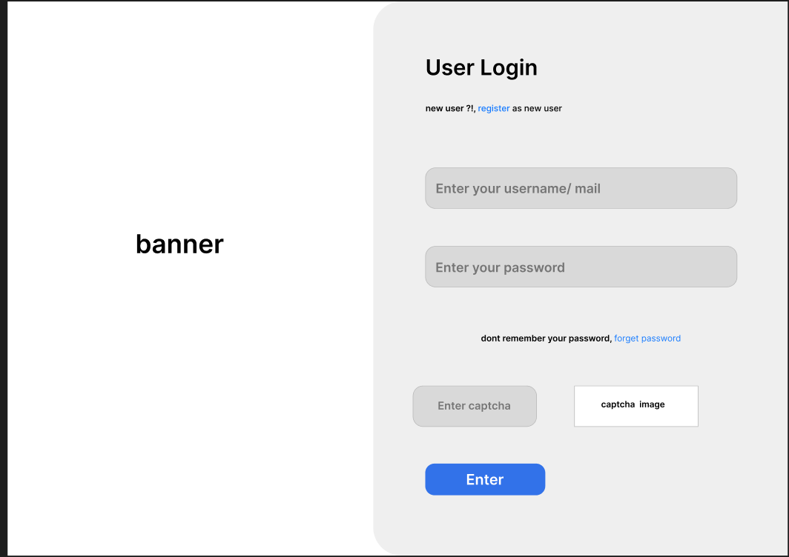

- Mockup
